We are working on Atherosclerosis (disease) and according to literature review , we Curcuma longa(Turmeric) has a properties to reduce the disease.
So in begaining , we chose 6 molecule with their screening-
Chemical Nmae | M.W. | Smile structure | Toxicity | no. HDM | No. HAM | logP
BIS-DEMETHOXYCURCUMIN | 308.3 g/mol | C1=CC(=CC=C1/C=C/C(=O)CC(=O)/C=C/C2=CC=C(C=C2)O)O | Class: 5 | 2 | 4 | 3.35
(+)-(S)-AR-TURMERONE | 216.32 g/mol | CC1=CC=C(C=C1)[C@@H](C)CC(=O)C=C(C)C | Class: 4 | 1 | 0 | 4.02
(+)-AR-TURMERONE | 219.34 g/mol | [2H]C([2H])([2H])[C@@H](CC(=O)C=C(C)C)C1=CC=C(C=C1)C | Class: 4 | 0 | 1 | 4.02
TETRAHYDROCURCUMIN | 372.4 g/mol | COC1=C(C=CC(=C1)CCC(=O)CC(=O)CCC2=CC(=C(C=C2)O)OC)O | Class: 5 | 2 | 6 | 3.21
Germacrone | 218.33 g/mol | C/C/1=C\CC(=C(C)C)C(=O)C/C(=C/CC1)/C | Class: 5 | 0 | 1 | 4.65

Ass we can see 2 molecules has toxicity level 5 so that I avoid that item and chose - BIS-DEMETHOXYCURCUMIN, TETRAHYDROCURCUMIN, GERMACRONE.
Those drug screening is done with protox and molsoft and swissadme software

Ok so according to the Dr. duke’s phytochemical database, I got those chemical and with the thlp of imppat database and genecards database what is the target gene of those chemical we get to know.
take the data from excel file
Then I identify the those all disease gene from gene cards data base and find the common gene of those target v/s disease gene by using venny 2.0.
I get 21 common gene that mean that iis the target of those chemical.
Now with the help of cystoscope hubba and string data base I get to know the hubgene and ppi beteen them and the exact pathways by using shinygo database the (KEGG pathway).
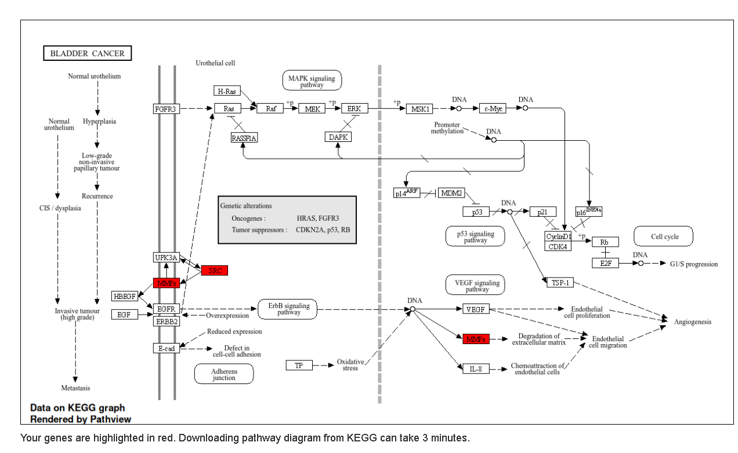
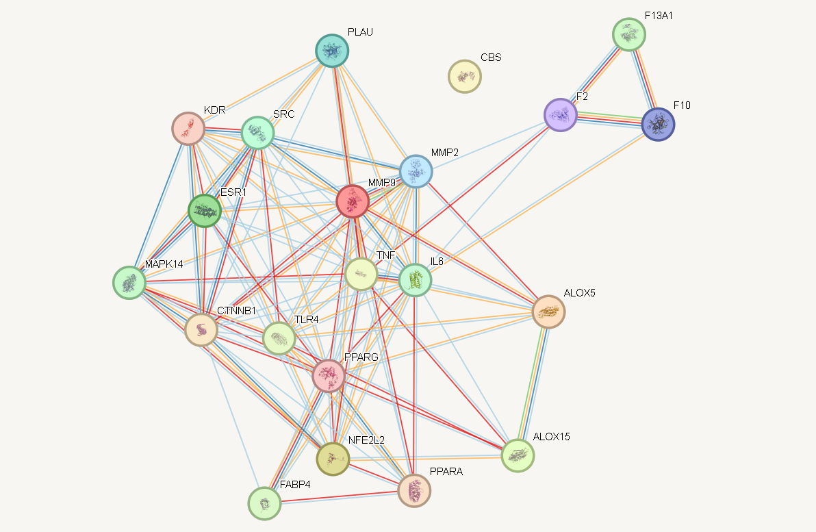

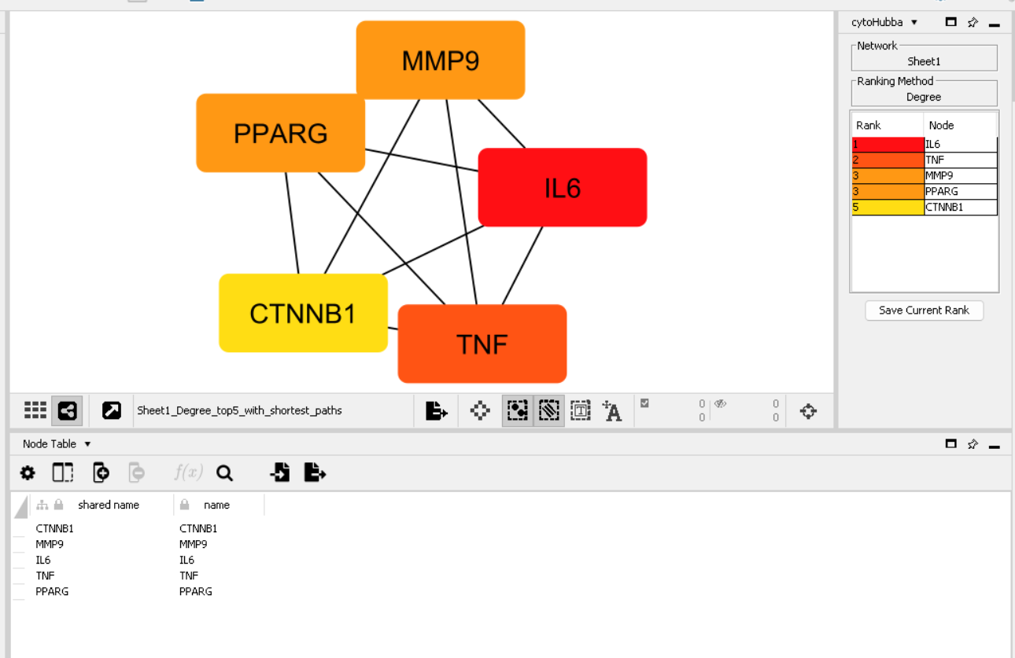
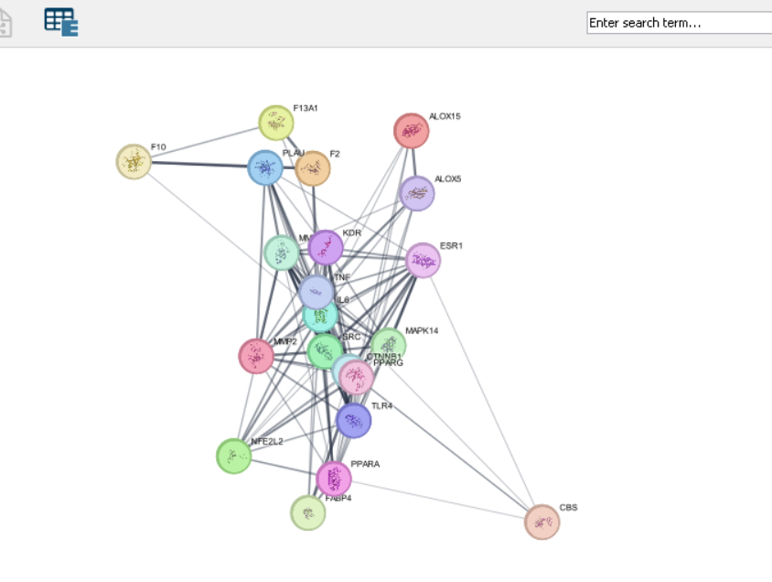

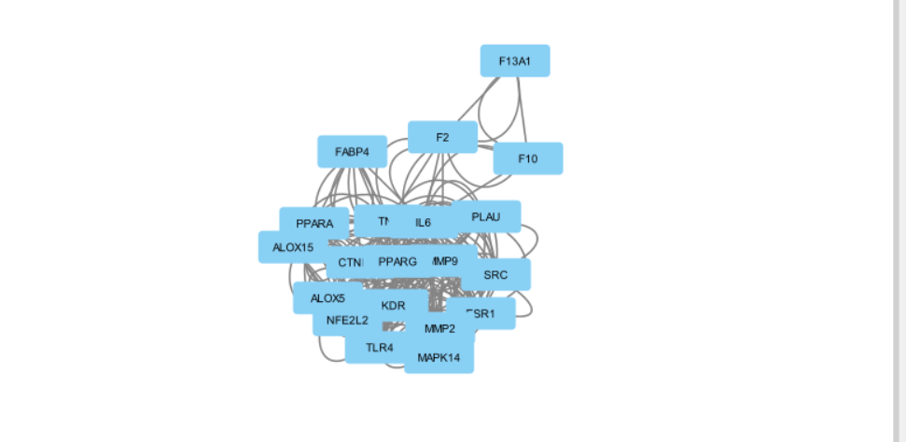

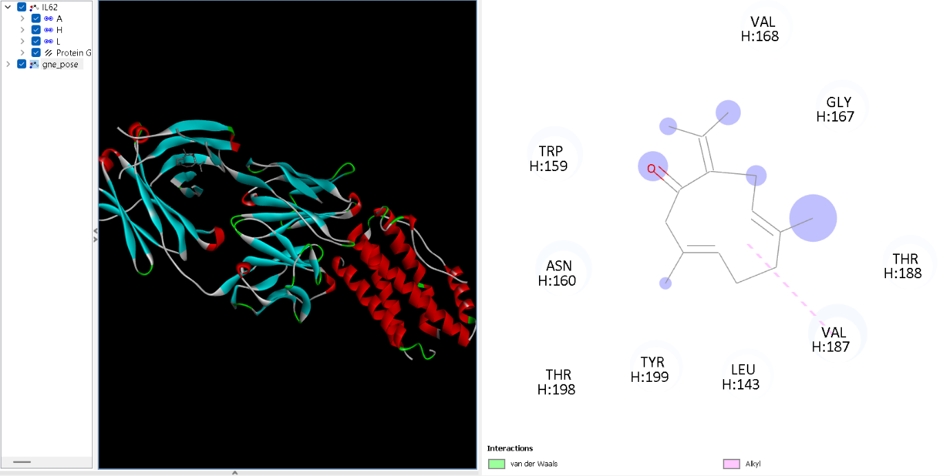

It the docking of Germacrone with IL6 protein because it is the top most hub gene .
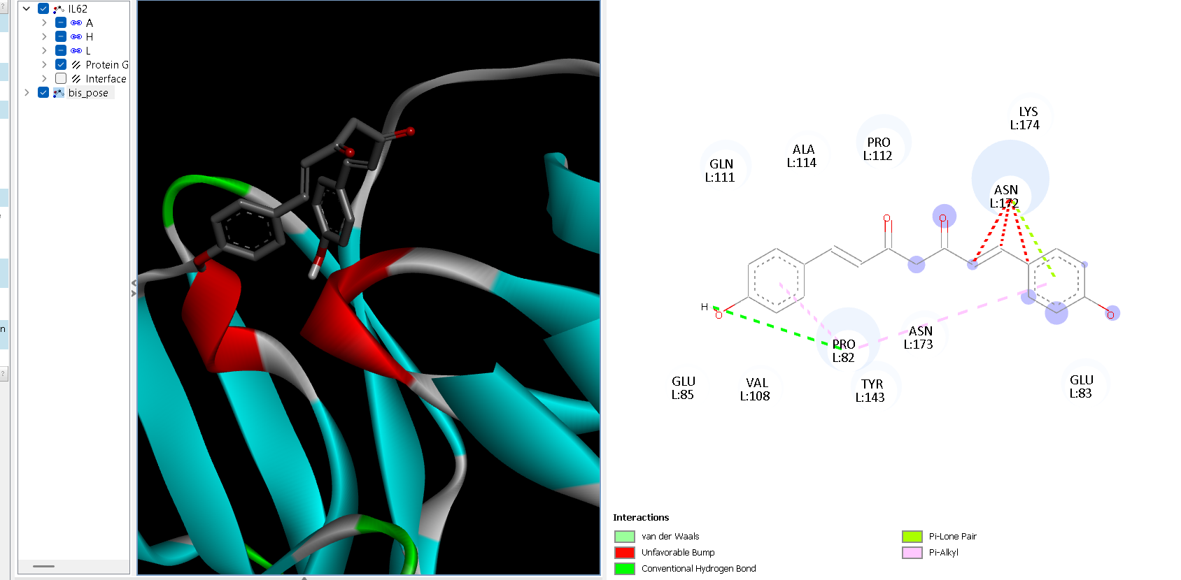

Docking with BIS-DEMETHOXYCURCUMIN with il6
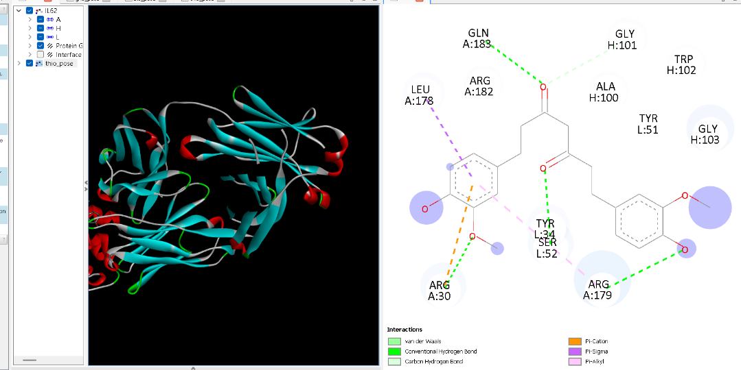

Docking with TETRAHYDROCURCUMIN.
For the docking use pyrx, biovia and autodock vina.

